**SOFTWARE ENGINEERING LAB-1 (TEAM 9)**

|  |  |  |  |  |  |  |
| --- | --- | --- | --- | --- | --- | --- |
| **Req ID** | **Type** | **Description** | **Priority** | **Acceptance Criteria** | **Rationale (short)** | **Comments** |
| FR-001 | Functional | The system shall allow a customer to select a coffee type (Espresso, etc.) | High | When a customer taps “Espresso,” the screen highlights Espresso and displays “Size” | Core ordering functionality | Good feature because customers can easily see and start their order |
| FR-002 | Functional | The system shall allow the customer to select a drink size. | High | When a size is selected, it is shown as chosen and the next step is prompted. | Required for price calculation and preparation | Helpful since it clearly shows options and guides the user smoothly. |
| FR-003 | Functional | allow a customer to customize add-ons (extra shot, soy/almond milk, syrups). | Medium | Add-on options are selectable, reflected in the order summary, and cost is updated immediately. | Proof of purchase & loyalty. | Better to make sure add-ons are shown neatly so people don’t get confused. |
| FR-004 | Functional | allow a customer to pay via credit/debit card or mobile wallet. | High | System connects to payment gateway; successful payment within ≤60 seconds; failure messages are displayed. | Ensures seamless payment. | Easy way for customers to finish payment without any trouble. |
| FR-005 | Functional | print a receipt showing order details and updated loyalty points. | Medium | Receipt includes drink, size, add-ons, total, payment confirmation, and loyalty points; printed automatically. | Proof of purchase & loyalty. | Nice because customers get proof of purchase and points directly. |
| NFR-001 | Nonfunc. | The system shall complete any order (selection to payment) in under 60 s. | High | A timing log shows < 60 s from first tap to transaction approval | Ensures quick service during peak hours | Fast service is important in a busy café so people don’t wait too long. |
| NFR-002 | Nonfunc. | ensure the kiosk operates reliably for at least 12 continuous hours without reboot or crash. | Medium | System uptime logs show ≥ 99% availability during 12-hour simulated cafe operations. | Ensures stability during daily service. | The kiosk should keep running smoothly all day without stopping. |

**Use Case Diagram :**  
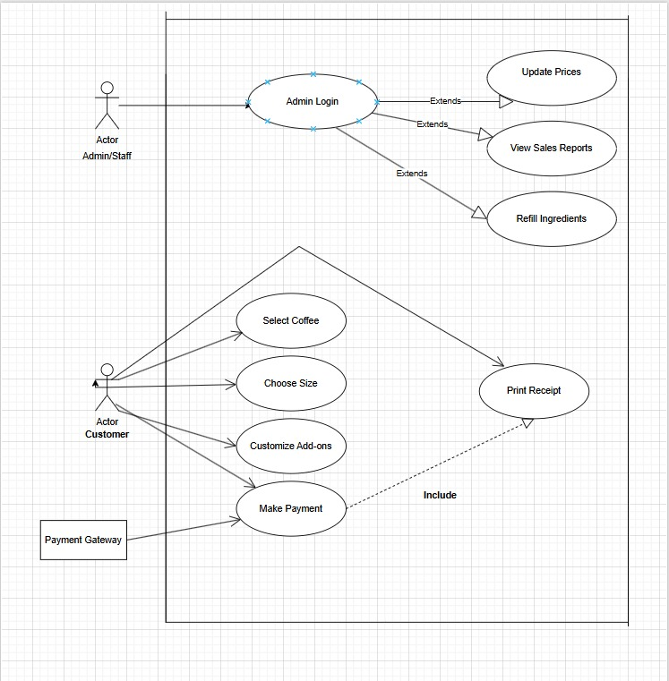

USE CASE FLOWS

1.**Select Coffee Type**

* **Actor:** Customer
* **Basic Flow:**
  + Customer selects coffee type (e.g., Espresso).
  + System highlights selection and prompts for size.
* **Alternate Flow:**
  + If no selection in 30s → System resets to welcome screen.

2.**Select Drink Size**

* **Actor:** Customer
* **Basic Flow:**
  + Customer chooses drink size.
  + System confirms size and prompts add-ons.
* **Alternate Flow:**
  + If invalid tap → System asks to reselect.

3.**Customize Add-ons**

* **Actor:** Customer
* **Basic Flow:**
  + Customer picks add-ons (milk, syrups, extra shot).
  + System updates summary and price instantly.
* **Alternate Flow:**
  + If no add-ons → System goes to payment.

4.**Make Payment**

* **Actor:** Customer
* **Basic Flow:**
  + Customer selects payment method (card/wallet).
  + System connects to gateway.
  + Transaction succeeds within 60s.
* **Alternate Flow:**
  + Payment fails → Show error & retry option.
  + If cancelled → Order discarded, system resets.

5.**Print Receipt & Update Loyalty**

* **Actor:** System
* **Basic Flow:**
  + System prints receipt with order details.
  + Loyalty points updated and displayed.
* **Alternate Flow:**
  + Printer error → Show receipt on screen with QR option.